7PAM2000 Applied Data Science

Assessment - 1

Student Name: **Charan Sai Prakash T**

Student ID: **21071658**

Table of Contents

About Dataset 2

References 4

# About Dataset

The data shows the rate of education rate of the female in the world and also given the explanation of last grade of primary education, age regardless and divide it to the population of the entrance age for the last grade of primary education. The data I take which is related to world bank group’s that was related to the rate of the education of female.

**The Database link: -**

<https://api.worldbank.org/v2/en/indicator/SE.PRM.CMPT.FE.ZS?downloadformat=csv>

**GitHub Repository Link:**

<https://github.com/Charan91120/Applied_data_science_1_assignment>

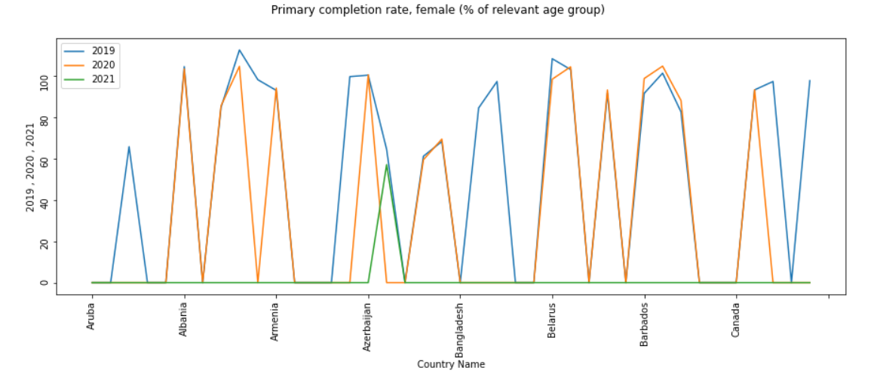

Figure : Plot 1

The above line graph describes the fluctuation of female’s education of the year 2019, 2020, 2021 based on the country name. This data shows the enrolments of students who drop out based on the year and shows the enrolments who enrol in the university to study continue.

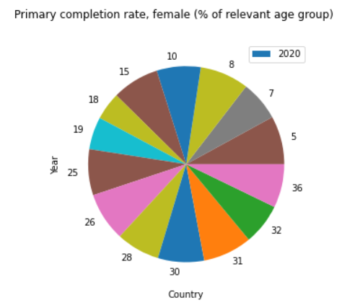

Figure : Plot 2

Pie graph describe about the enrolled female students of the 2020 year as per the % relevant age group of the primary completion rate. The dataset I used in this assignment it shows the percentage of relevant age group of primary completion rate. The Pie graph is the best choice to show the percentage type of data and it also show the relationship with the country name and other relevant fields in the dataset.

This statistic shows the grades calculated by the dividing number of new entrants’ students and minus all the repeaters of the last year (Landup, 2021).

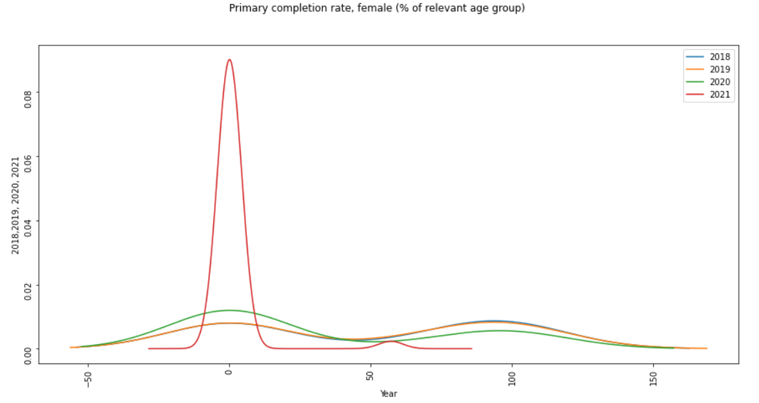

Figure : PLot 3

I used the kde plot to know the density estimators of the female percentage of educated students.

The kde refers to the kernel density estimators that is used to describe the randomness of the data.

The kde plot shows the data in the wave form and give the simple explanation of the data of females. The above kde plot used to show the three-year statistic of primary female completion rate and the ratio of the last grade of primary education and put the data into the limits to show the graph as per my requirements and give the good visualization of the years based on the final year of primary education students (Tech, 2022).

# References

Landup, D. (2021). *Matplotlib pie chart - tutorial and examples*, *Stack Abuse*. Stack Abuse. [Online]. Available at: https://stackabuse.com/matplotlib-pie-chart-tutorial-and-examples/ (Accessed: November 9, 2022).

Tech, A. (2022). *KDE plots*, *Ajay Tech*. [Online]. Available at: https://ajaytech.co/kde-plots/ (Accessed: November 9, 2022).